TNE20003 – Internet and Cybersecurity for Engineering Applications

**Portfolio Task – Lab 9 Pass Task**

Aims:

* To observe and investigate tunnelling in a network.

Preparation:

* View [“Introduction to Cybersecurity”](https://swinburne.instructure.com/courses/54168/pages/topic-9-intro-to-cybersecurity?module_item_id=3765162) & “[Cybersecurity”](https://swinburne.instructure.com/courses/54168/pages/topic-10-cybersecurity?module_item_id=3775875)

Due Date:

* All tasks in this lab are to be completed and demonstrated to your Lab instructor preferably during or at the end of the current lab, but if you do not complete the tasks you may demonstrate it at the beginning of your next lab class.

# Task 1

Get an understanding of the lab.

The purpose of this lab is to investigate tunnelling, in particular to consider how this and similar software can be used to subvert a security program. We will be examining tunnelling of telnet but the general principles can be applied to other protocols.

Telnet is used because it is a simple protocol with messages transmitted without encryption (“in clear text”). Of course, this also makes it a very insecure protocol and you should never use telnet when there are alternatives. Do not under any circumstances interpret the use of telnet in this lab as a recommendation for it to be used anywhere else.

You will use the Wireshark packet sniffing system and open source http tunnel software. You will use Wireshark to examine the packets.

This work is to be carried out in the VMWARE environment. We will be running two Linux Ubuntu virtual machines.

You may be asked for a password. All passwords are **user**

This lab uses the GNU http tunnelling software. It provides two tunnelling programs: **hts** and **htc**. **hts** is installed on the server system to accept tunnels from a specified port number and transfer them to another port number. **htc** is used to communicate to **hts** to set up a tunnel.

Assessment of this lab is through you demonstrating the working tunnel and wireshark output to the lab demonstrator and answering some questions (listed at the end of the lab) that the demonstrator will ask you.

# Task 2

This lab uses Linux Virtual Machines (VMs) running in via VMWARE. If you are unfamiliar with Linux please spend some time before the lab learning some of its basic commands.

The VMs are both available via the start menu. To get them started do the following:

1. Go to Start menu > Virtual Machine Launcher. You will be presented with the following window:

Choose the TNE30009 Network Security tab. You will be presented with three VMs. Download Ubuntu 1 and Ubuntu 2. This may take a few minutes.

Launch the VMs. You may be asked to update the VMWARE software or the Ubuntu version. Ignore these.

1. You should now have two Ubuntu VMs running.

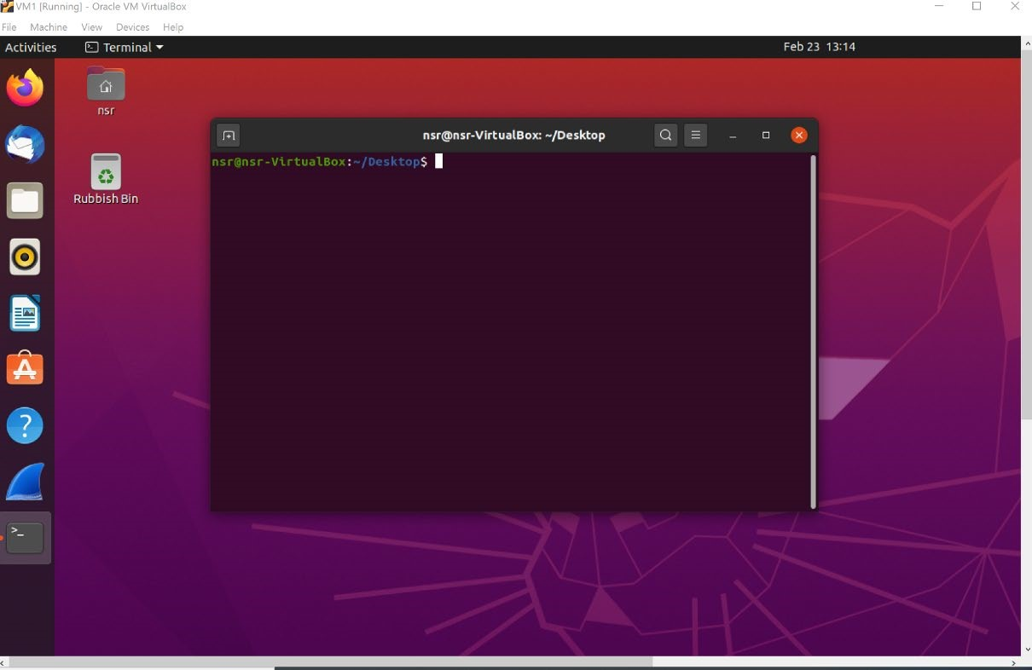

1. You will need to work within the terminal. Right click your mouse and choose “**Open in Terminal**”. You can determine your IP address with the command **ifconfig**. The interface you will be monitoring is **ens33**. It should have an IP address assigned from 192.168.0.0/16 with both hosts on the same /24 subnet.
2. Once both VMs are running determine their IP addresses and confirm they are on the same subnet. Use

**Ifconfig**

1. You should now be able to ping between the two VMs. Make sure you can.

**ping <ip address>**

# Task 3

To set up the tunnel, choose one machine to be the tunnel server and the other to be the tunnel client. You will telnet via the tunnel from the tunnel client to the tunnel server. You are to determine the addresses and port numbers to use in the command below.

On the server machine use the following command to accept tunnelled messages from port 80. Messages are to be forwarded to the telnet server listening on port 23.

**sudo hts –F <IP address to forward to>:<forwarding port number> <receiving port number>**

On the client machine use the following command to initiate a tunnel to the server machine over port 80.

Use 2323 as the receiving port number.

**sudo htc –F <receiving port number> <IP address to forward to>:<forwarding port number>**

# Task 4

To monitor the traffic start Wireshark. Monitor the ethernet port which will usually be **ens3.**

Initiate a telnet session via the tunnel from the client. The format of the telnet command is:

**telnet <IP address of tunnel client> <receiving port number>**

You should receive a telnet login request. Login with user **nsr** and password **user**.

Using Wireshark you should be able to see the transmitted traffic. Note how the telnet traffic is tunnelled.

Your output should something like the diagram below:

# A screenshot of a computer program Description automatically generatedA screenshot of a computer Description automatically generatedA screenshot of a computer Description automatically generatedA screenshot of a computer program Description automatically generatedA screenshot of a computer Description automatically generatedTask 5

Assessment of this lab

This lab will be assessed with a discussion between you and the lab supervisor. You will need to demonstrate that you have successfully completed the lab. He or she will also ask you the following:

1. What command is needed on the tunnel server to accept tunnelled messages on port 80 and send them to port 23 on the local host? Include the IP addresses that you used.

sudo hts -F 192.168.1.2:80 23

1. What command is needed on the tunnel client to tunnel messages to and from port 2323 to and from port 80?

sudo htc -F 2323 192.168.1.2:80

1. What did Wireshark interpret the tunnelled traffic as?

Wireshark interpreted the tunnelled traffic as telnet traffic over port 80. Telnet is a clear text protocol for remote terminal access, and in this case, it was tunnelled over HTTP port 80.

1. How did the tunnelling software attempt to hide the traffic?

The tunnelling software attempted to hide the traffic by encapsulating the telnet traffic within HTTP requests and responses. This makes it appear as regular HTTP traffic over port 80, which is a common and less suspicious port for web traffic.

1. How might tunnelling of this kind be used to subvert security policy?

Tunnelling of this kind can be used to subvert security policies by disguising potentially malicious or unauthorized traffic as legitimate web traffic. Since it's using port 80, which is typically allowed for web traffic, it can bypass firewall rules and security measures that may not inspect the content of the traffic. This can be used to exfiltrate data, evade network restrictions, or even execute remote commands in a way that goes undetected by traditional security mechanisms.